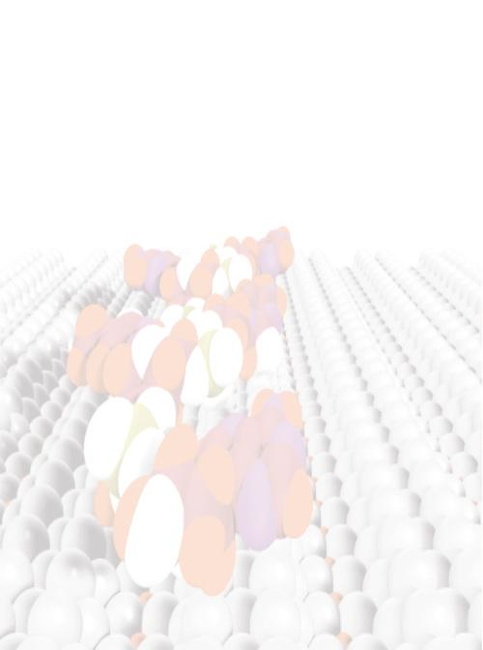
NANOBIOMEDICINE
Juli 2-3, 2004
University Hospital Hamburg-Eppendorf
Registration Form
The participation is free of any congress fee.
Title: Gender: f m
First Name: Last Name:
Company:
Department:
Street / P.O. Box:
Postal Code: City:
e-mail:
I want to attend the congress on
Friday, 2.7.2004
Saturday, 3.7.2004
Date: Signature
Return to congress office by fax or email: Mrs. Brenger
Tel.: 040 / 42838 – 7045
Fax: 040 / 42838 – 6959
email: ubrenger@physnet.uni-hamburg.de
